**DAILY ONLINE ACTIVITIES SUMMARY**

|  |  |  |  |  |  |  |  |
| --- | --- | --- | --- | --- | --- | --- | --- |
| **Date:** | | **5/6/2020** | | | | | |
| **Name of the Faculty** | | **REENA LOBO** | | | | | |
| **No. of Students Allotted for monitoring** | | | | | **19** | | |
| **Progress** | | | | | **GOOD** | | |
| **Whether collected report from all the allotted students** | | | | | **18,not submitted-ramitha** | | |
| **Online Test Summary** | | | | | | | |
| **Subject** |  | | | | | | |
| **Semester** |  | | | **Duration** | |  | |
| **No. of students Taken** | | |  | **Passing %** | |  | |
| **Certification Course Summary** | | | | | | | |
| **Course** | | 1**.Attended webinar on  Improving the Skill Set & Changing the Attitude**.  **Certification provider: sky campus**  **Duration:1.30hr**  **2.attended webinar on BRAIN COMPUTER INTERFACE**  **Certification provider:pantech soluton**  **Duration:2hr**  **3.particiated in quiz on BASIC SCIENCE AND TECHNOLOGY**  **Crtification provider:Don Bosco college** | | | | | |
| **Certificate Provider** | |  | | | **Duration** | |  |
| **Coding Challenges** | | | | | | | |
| **Problem statement:** **Write a Java Program to find the duplicate characters in a string.**  **Language used for solving: JAVA**  **Whether posted in Github: YES**  **Link:** <https://github.com/orgs/alvas-education-foundation/teams/2nd-year/discussions/101>  **How many students attempted :28** | | | | | | | |
| **Status: COMPLETED** | | | | | | | |
| **Uploaded the report in Github** | | | | | **yes** | | |
| **If yes Repository name** | | | | | <https://github.com/reenalobo/ONLINE-ACTIVITY-REPORT/upload/master> | | |
| **Uploaded the report in slack** | | | | | **yes** | | |

Certification Course Details: (Attach the snapshot and briefly write the report for the same)

**Attended webinar on  Improving the Skill Set & Changing the Attitude**.

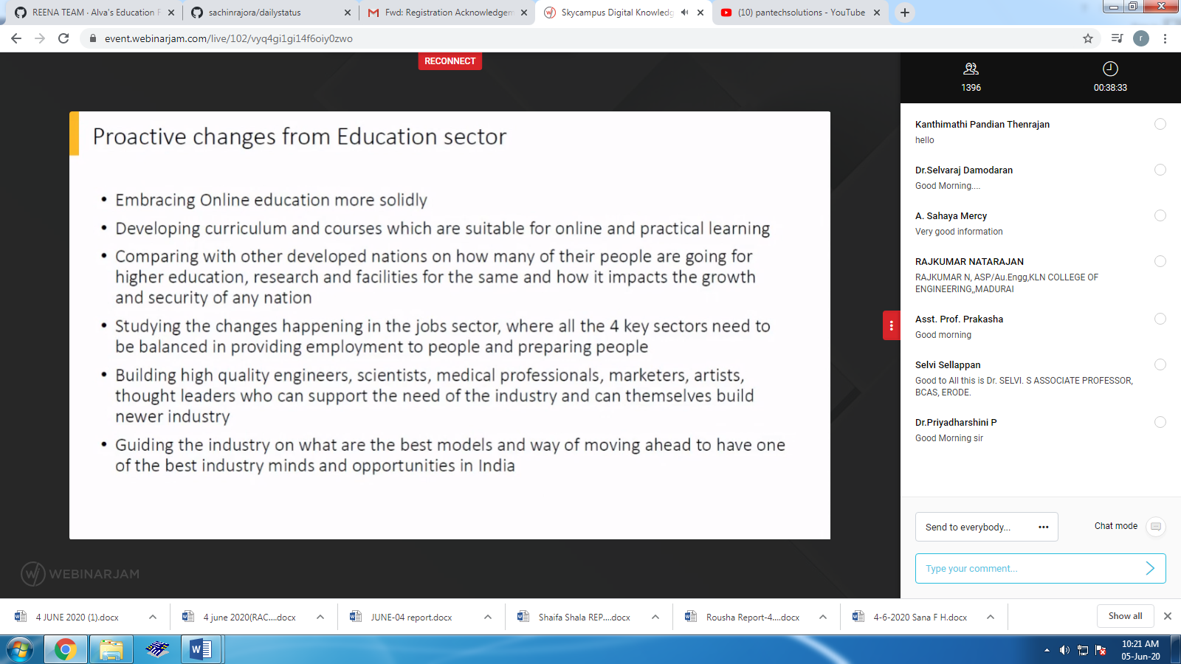

**.attended webinar on BRAIN COMPUTER INTERFACE**

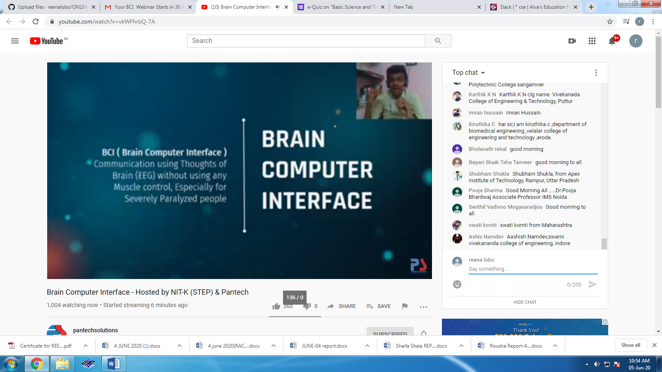

STUDENTS REPORT:

Ravali:

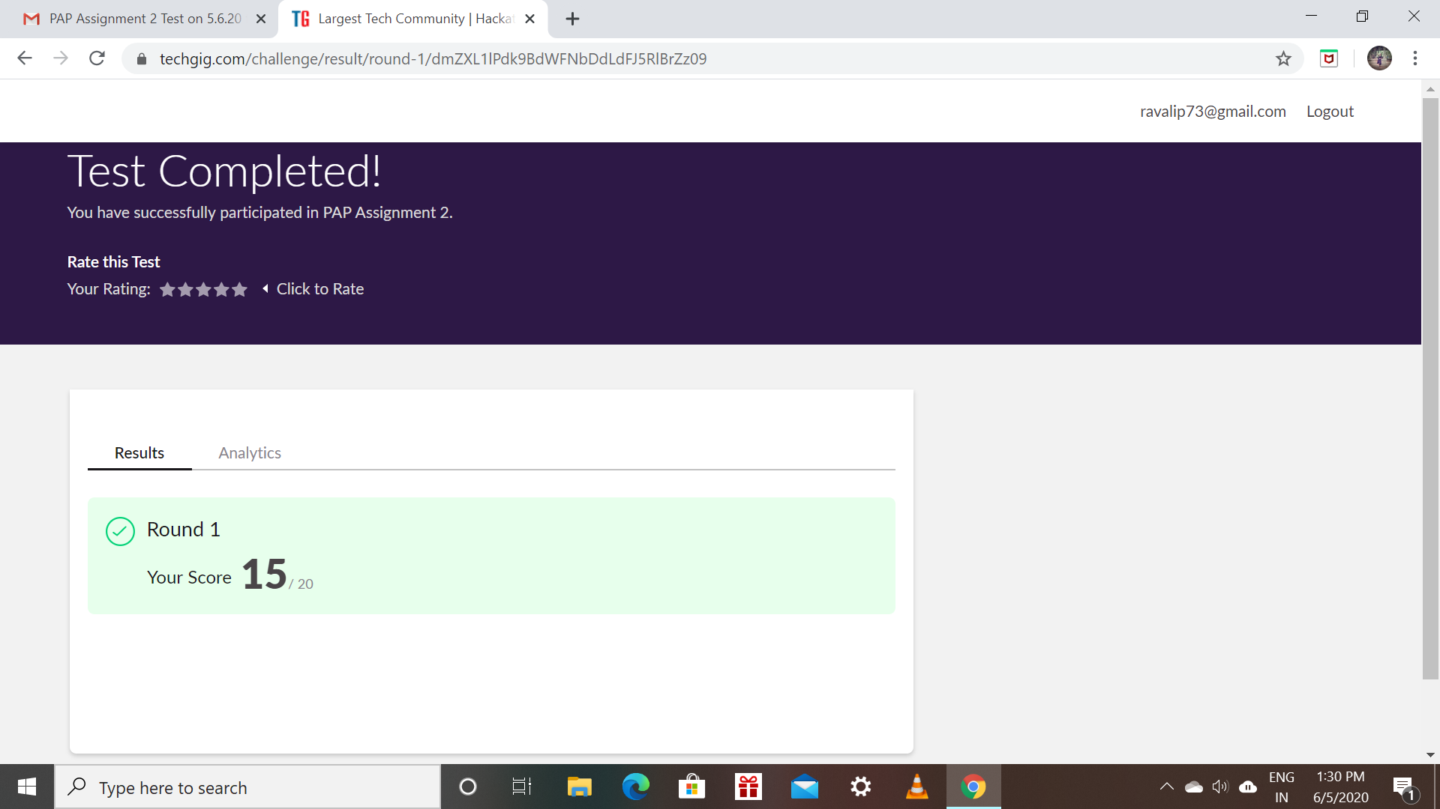

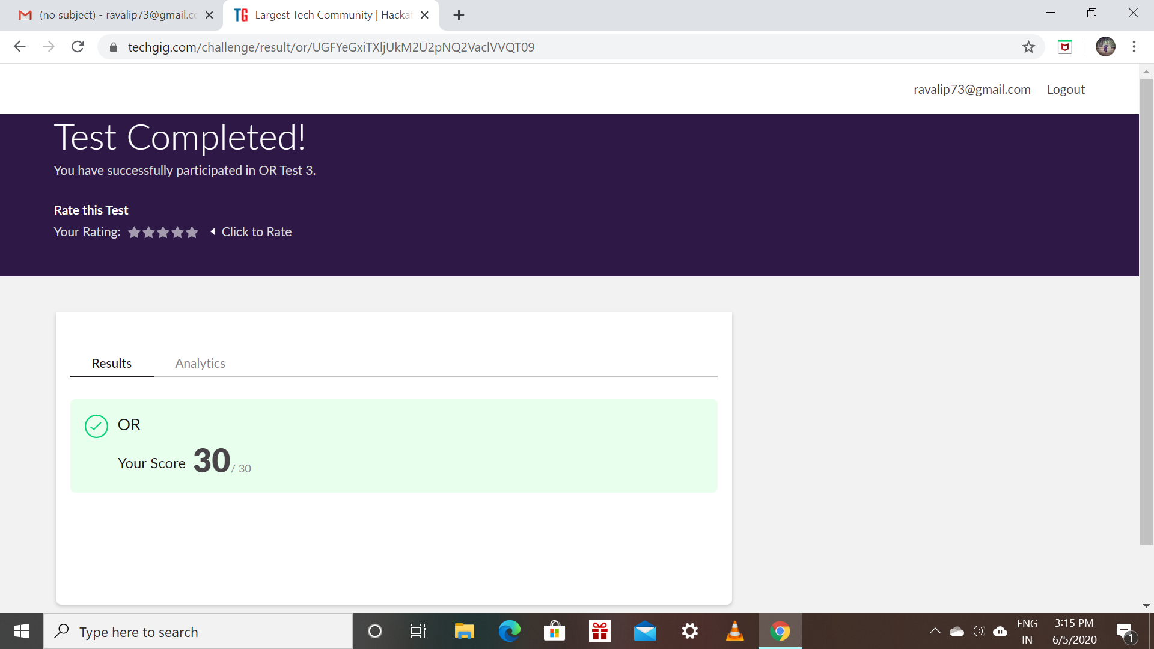

Raksha:

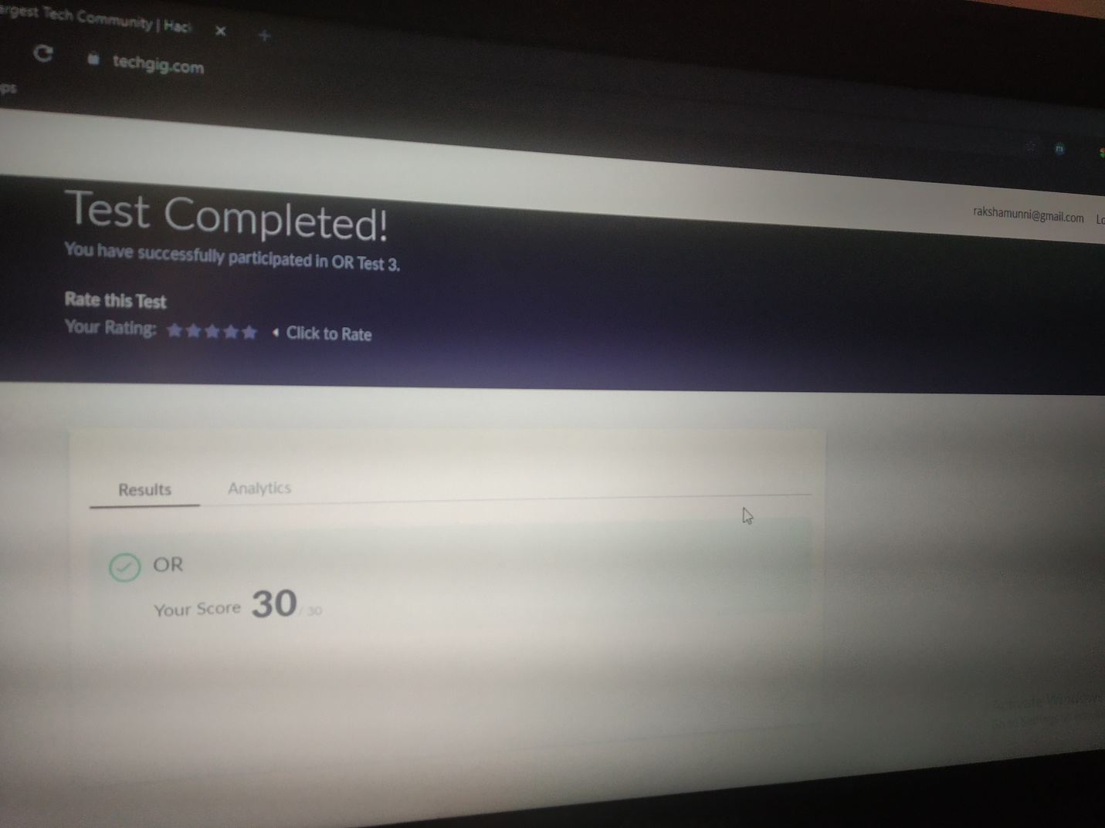

Scored 30 out of 30 in OR Test

Certification Course Details:

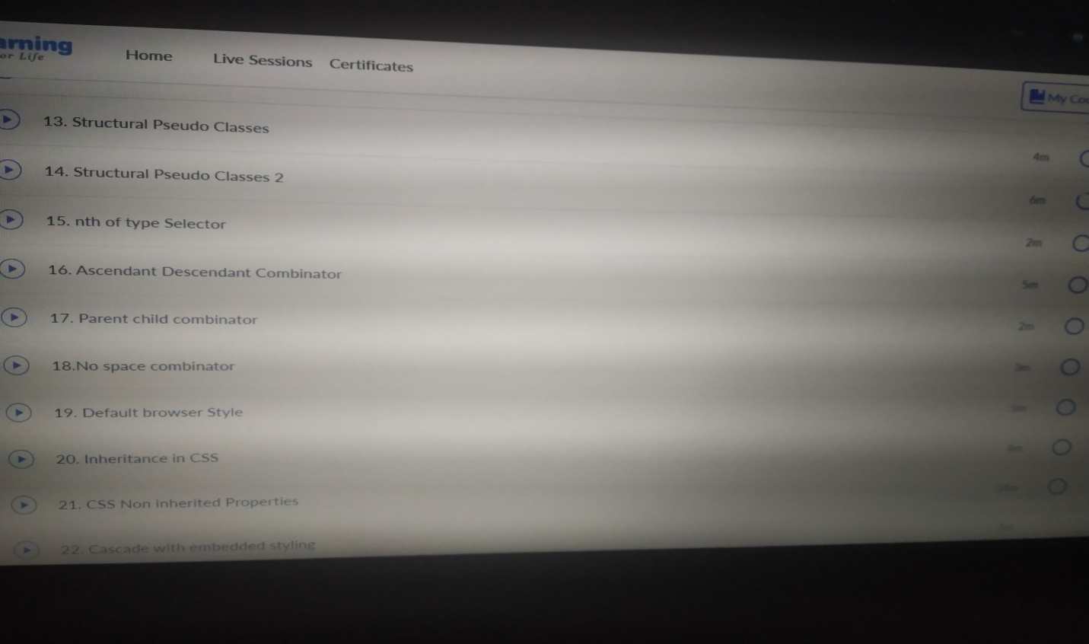

Rohan mahaveer:

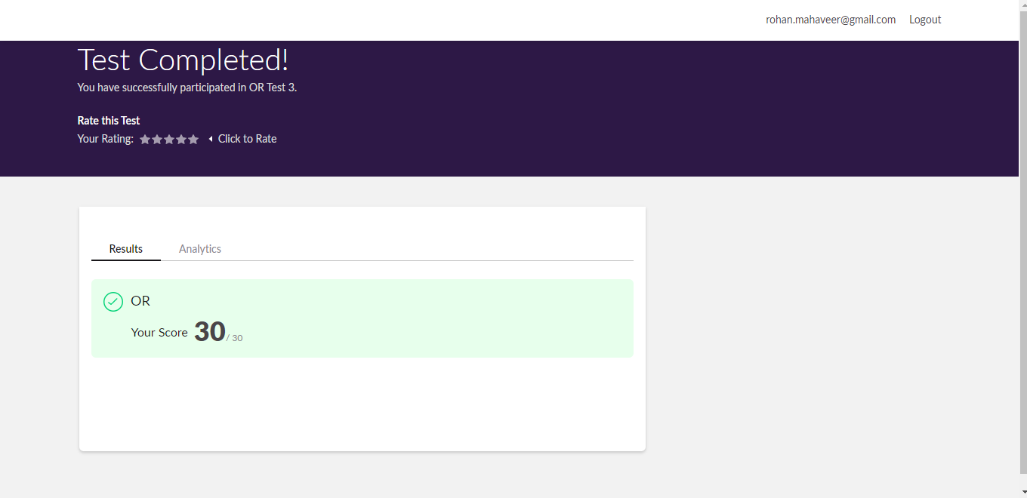

Scored 30 out of 30 in OR Test

Certification Course Details

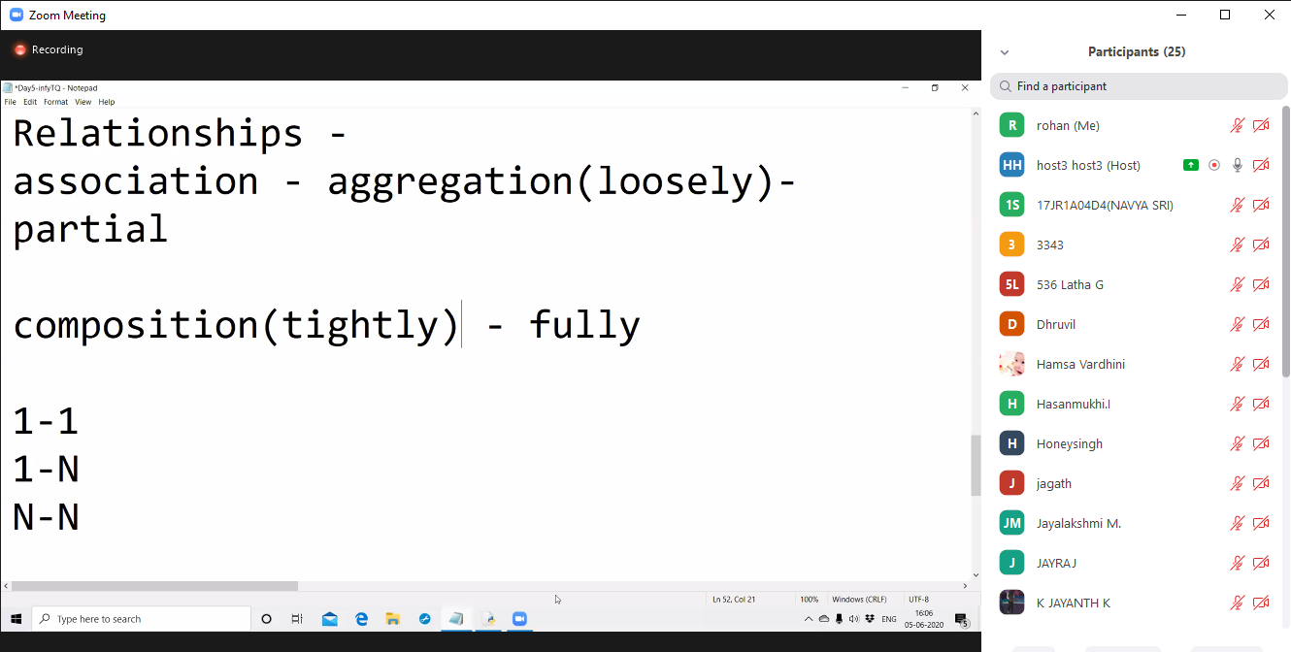

Preethi

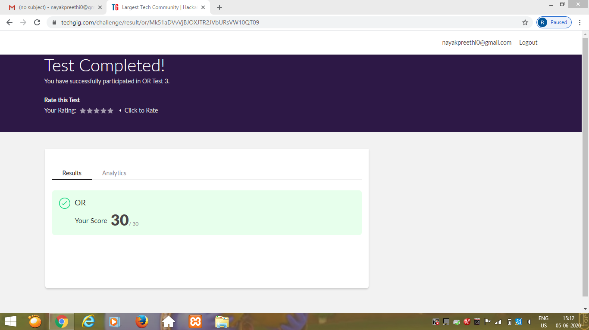

Certification Course Details: (Attach the snapshot and briefly write the report for the same)

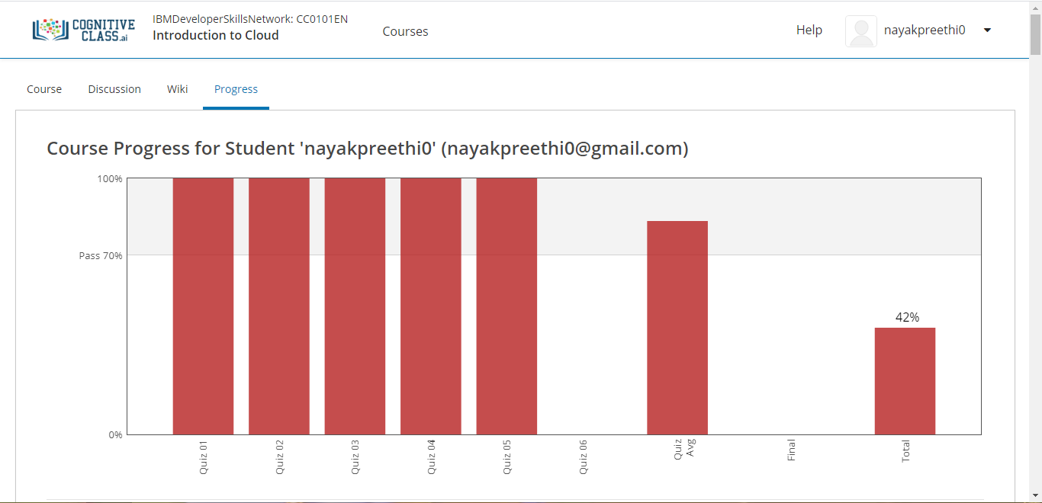

Pranav:

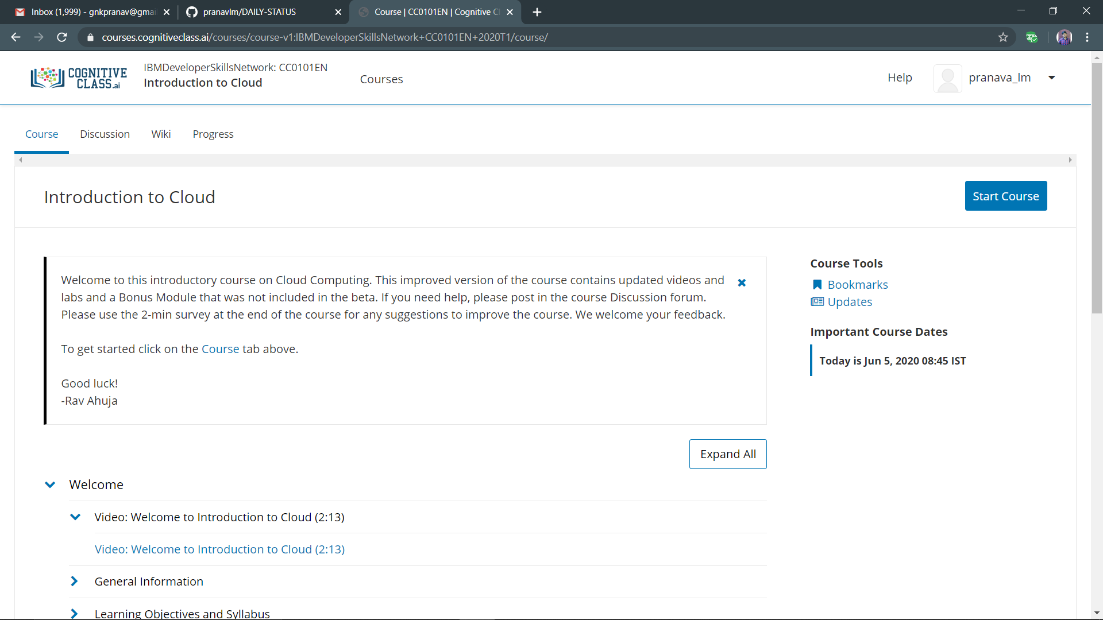

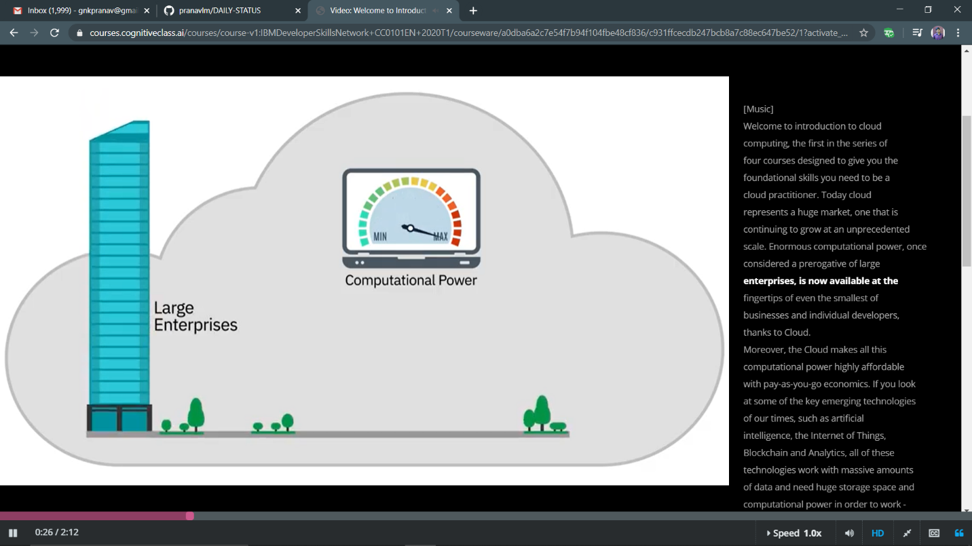

Rani:

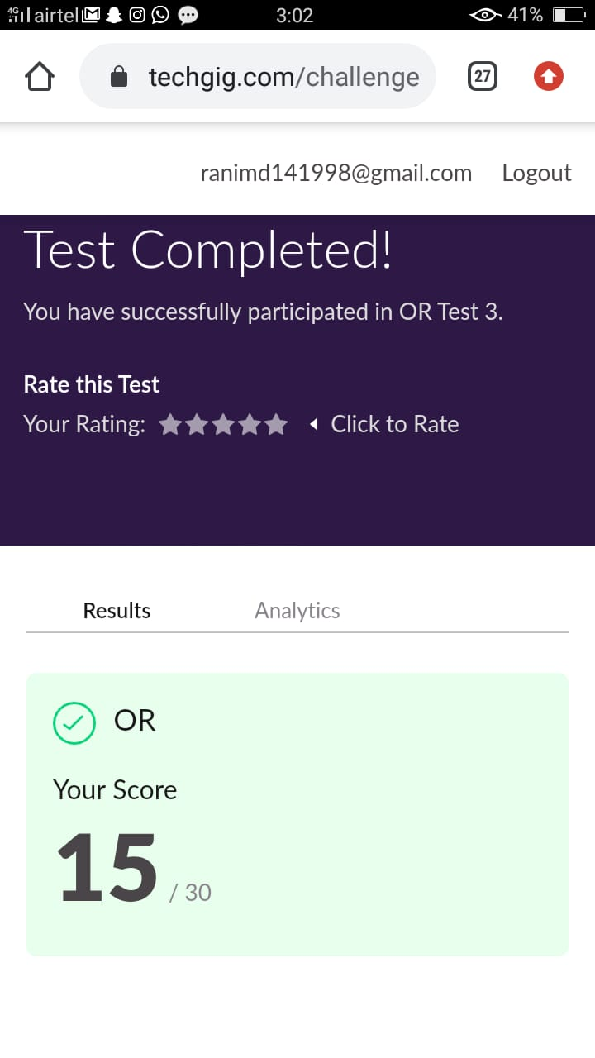

Rachana:

**OR:**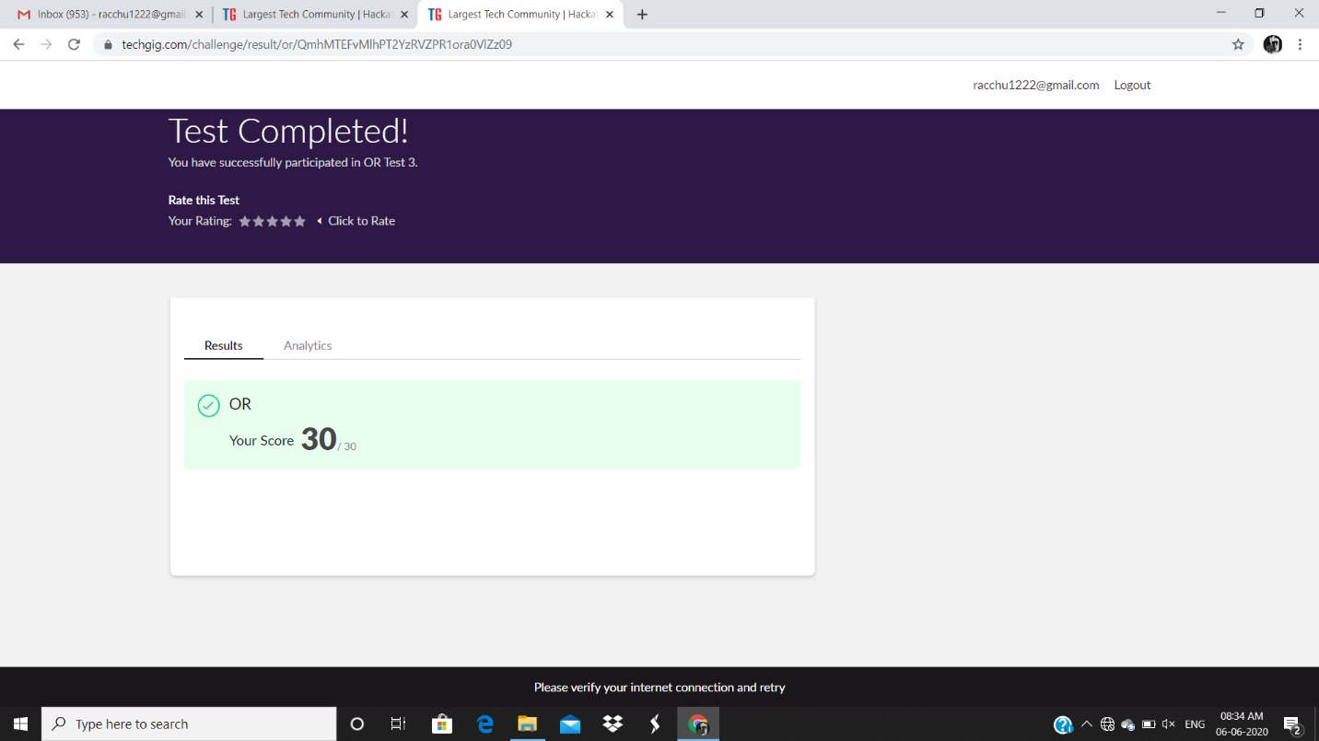

Priyanka:

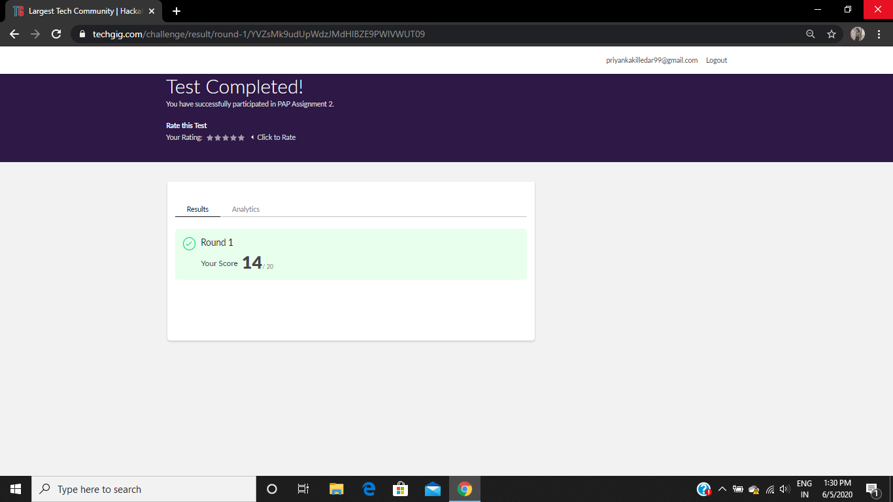

**OR:  
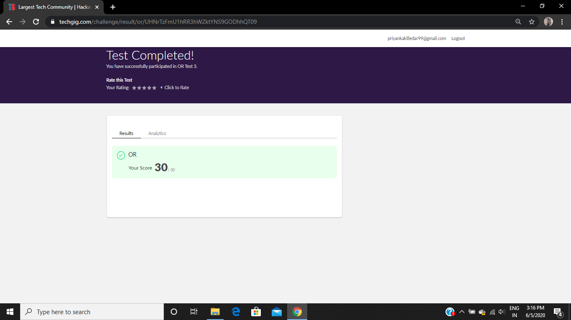**

**Certification Course Details:**

**E-Box Classes:**

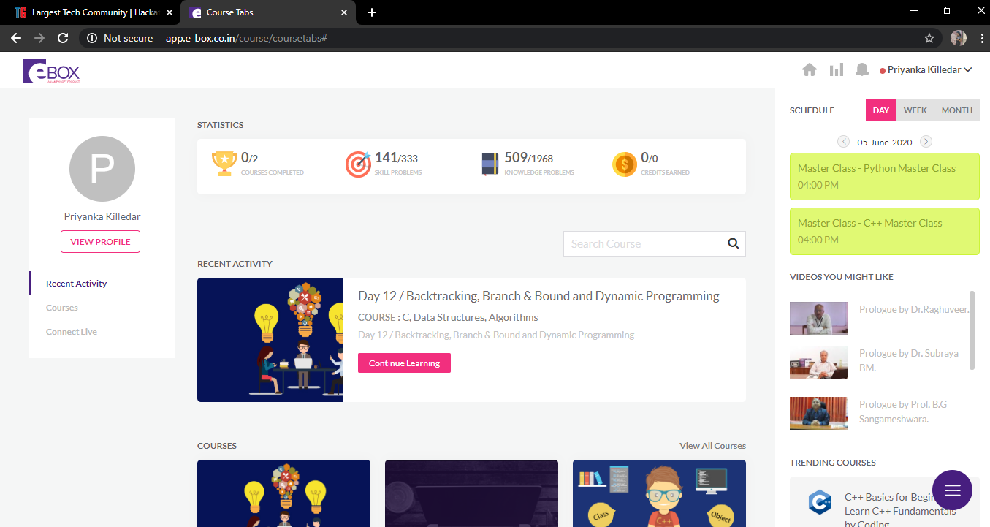

* **PYTHON CLASS:**

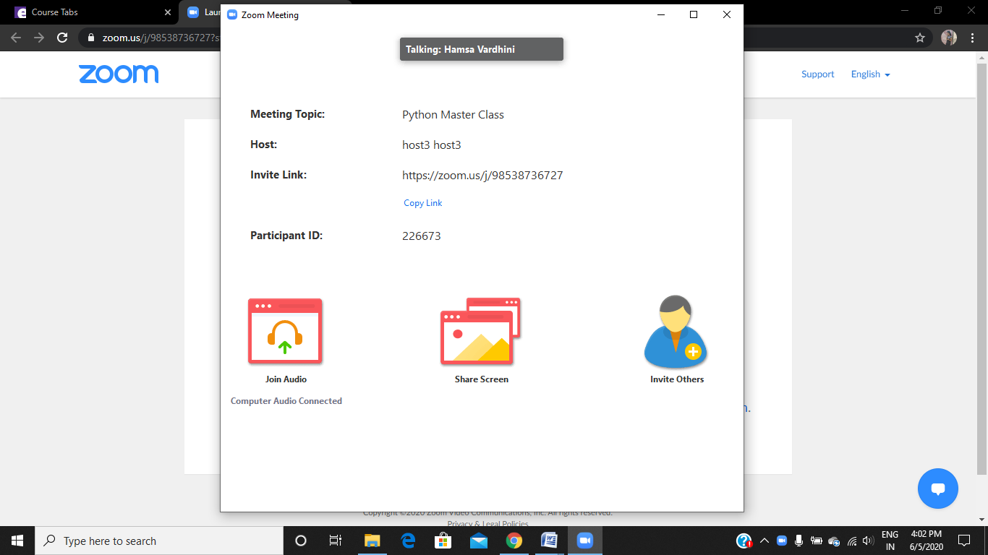

Sana:

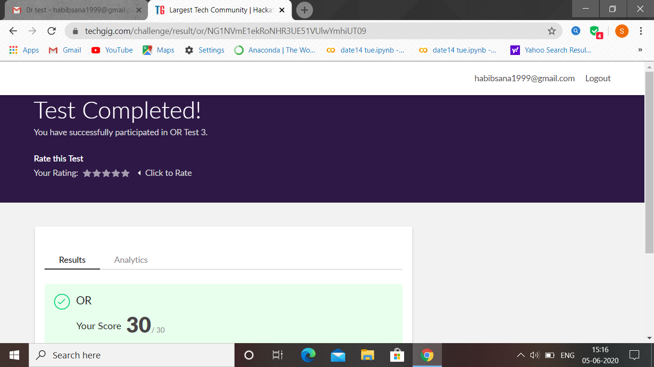

OR test 3 was held today. i.e 5 June 2020. Out of 30 marks I scored 30

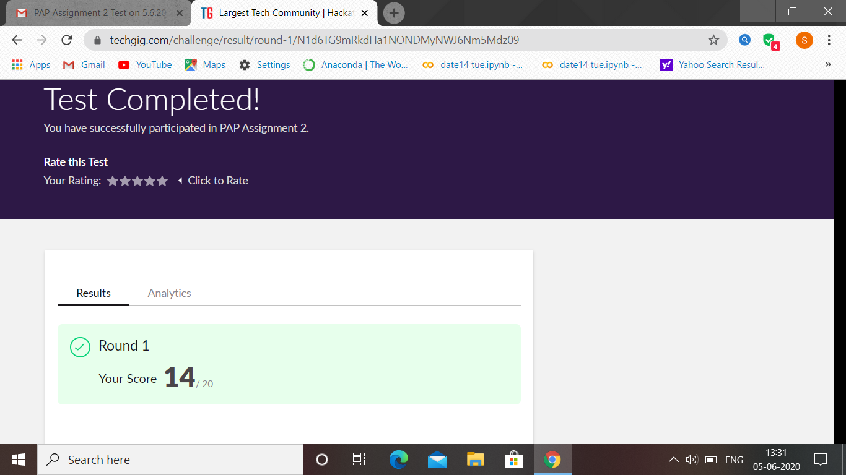

PAP assignment test 2 was held today. i.e 5 June 2020. Out of 20 marks I scored 14

Certification Course Details: (Attach the snapshot and briefly write the report for the same

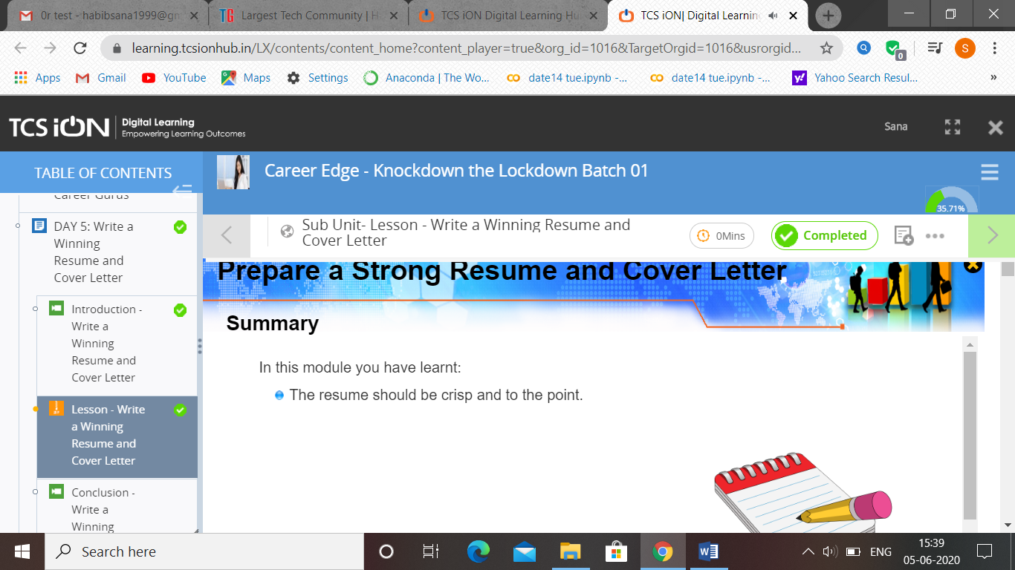

(5-06-2020)-Career Edge. TCS-A winning resuming and cover letter.

Atish:

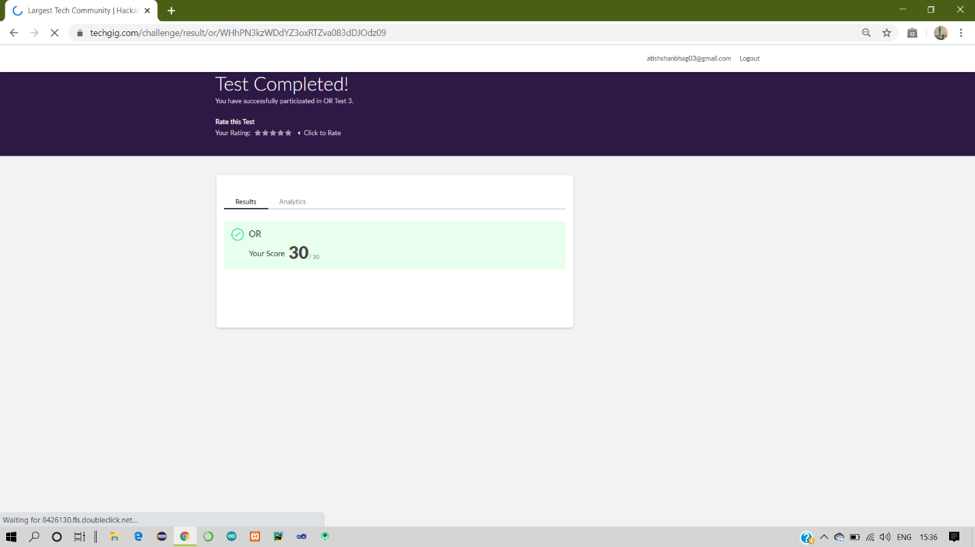

Certification Course Details:

Report

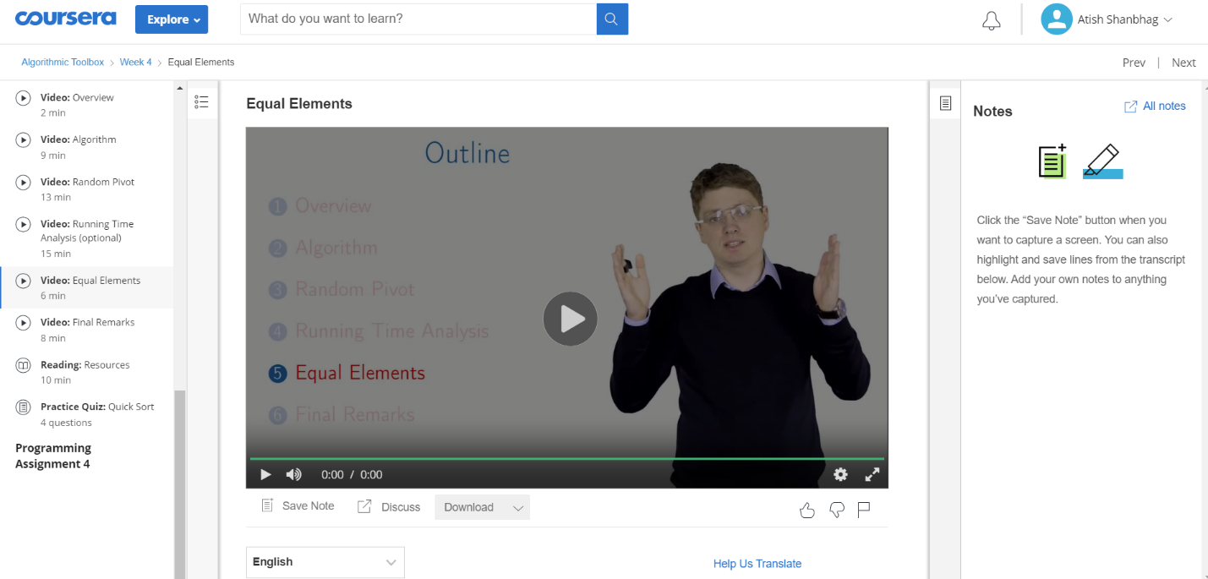

Dhruvil:

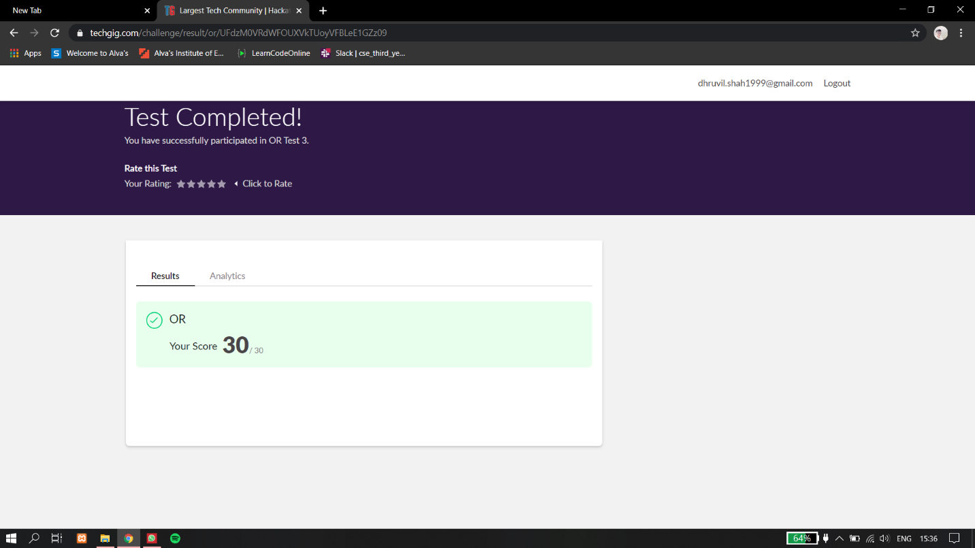

Certification Course Details:

Report

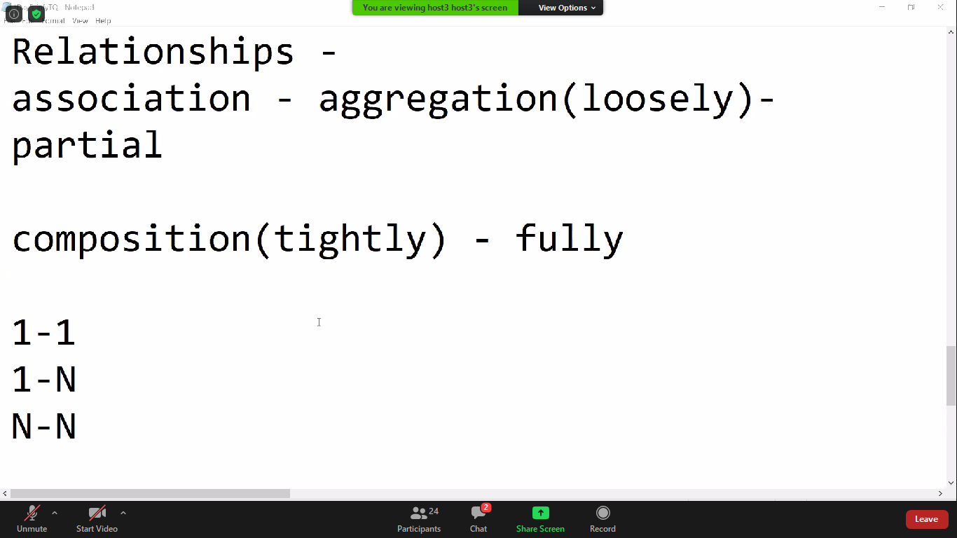

Priya ht:

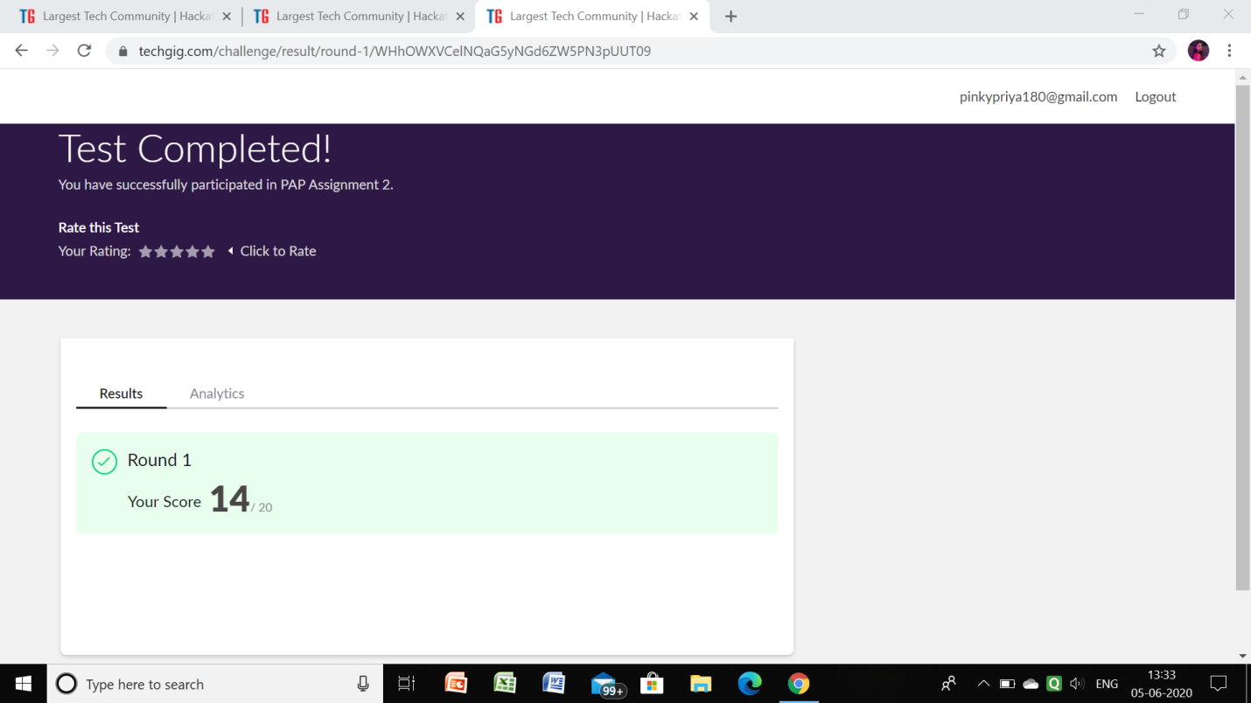

OR:

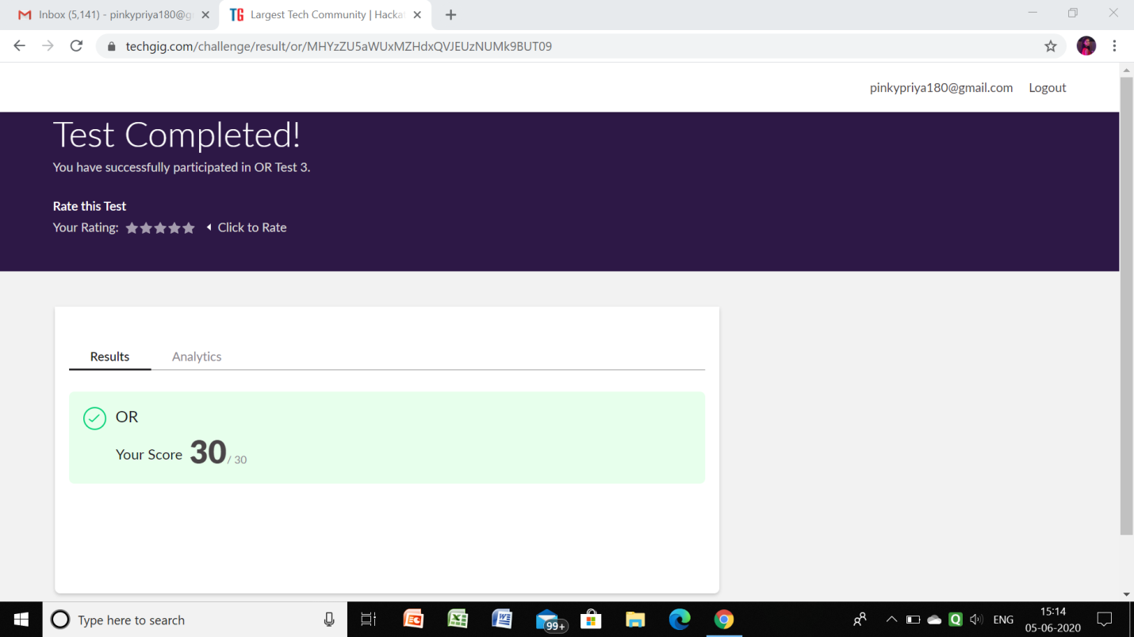

Rohan vasista:

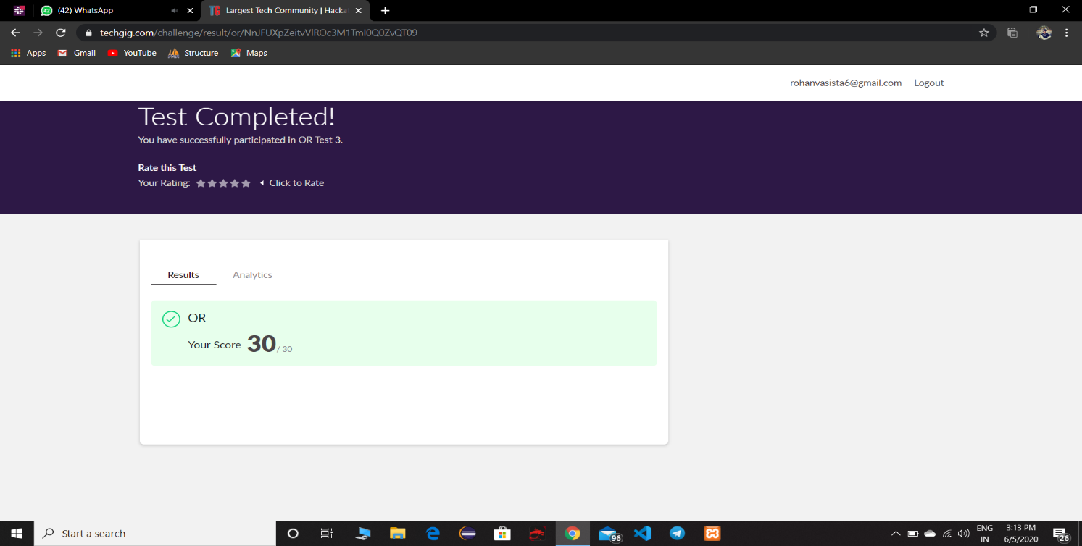

**Certification Details**

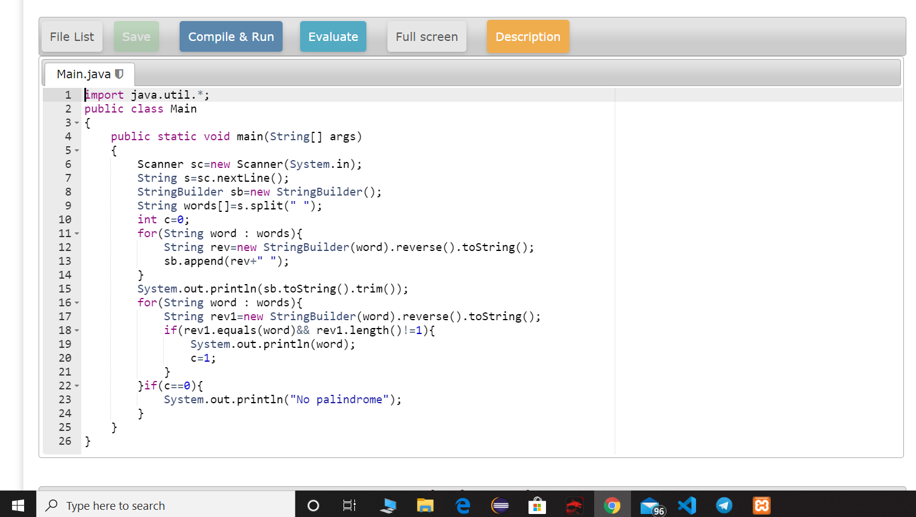

**Coding Challenge Details**

Praveen kumar:

certification course snap

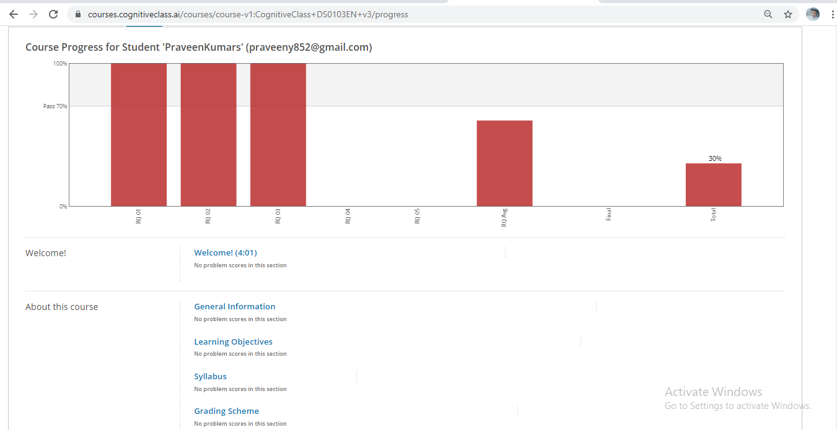

Raghavi:

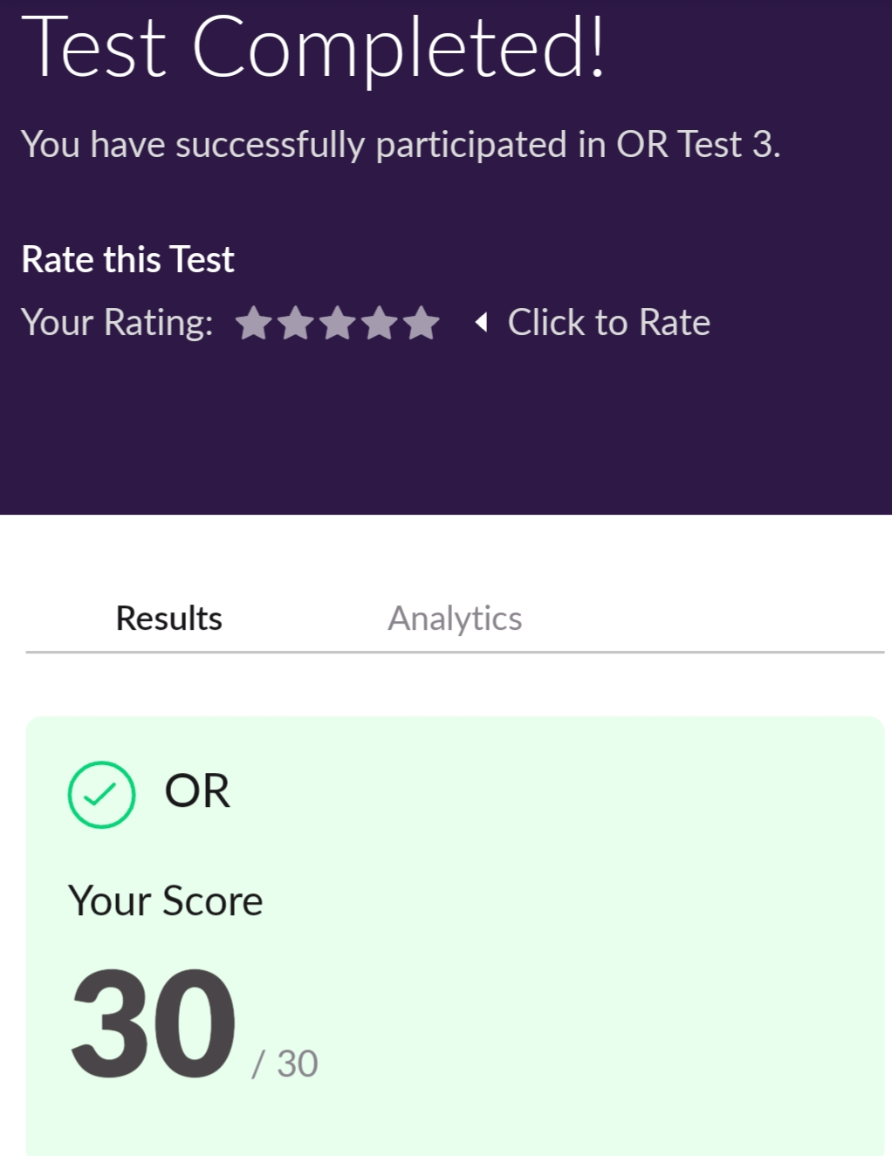

Certification Course Details:

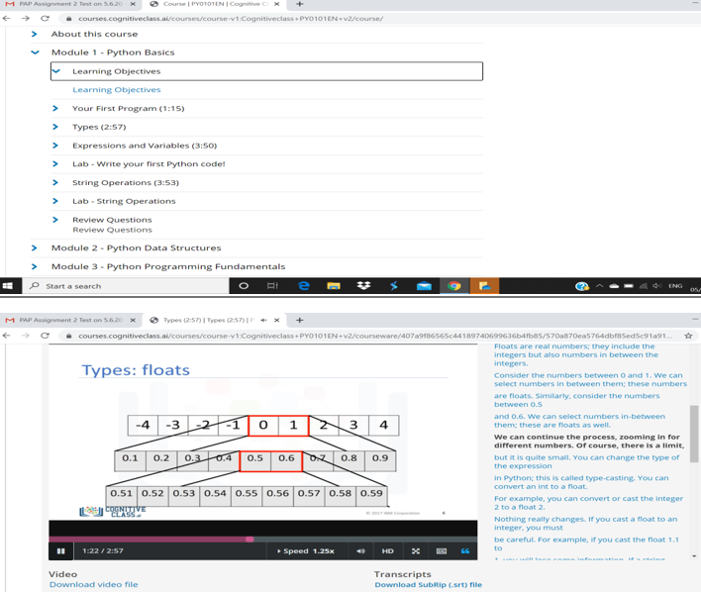

Sachin:

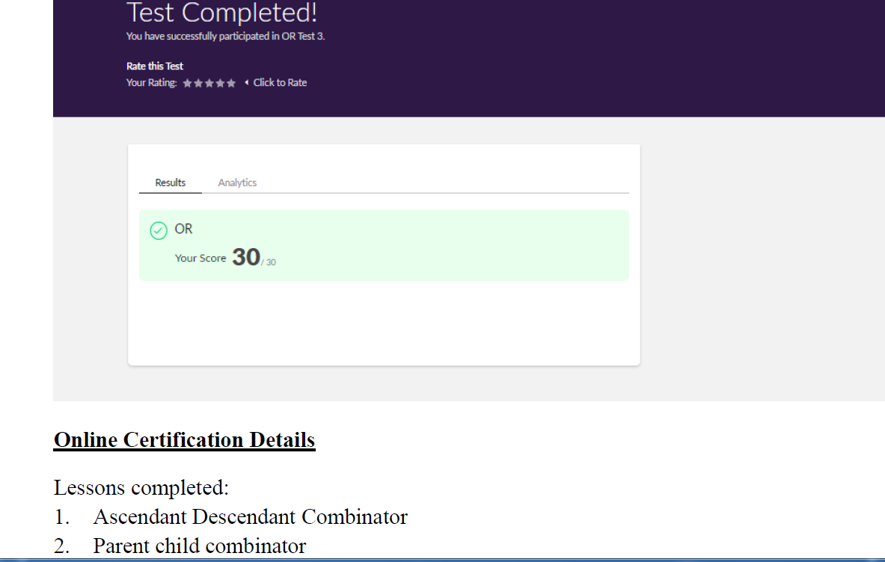

Rousha:

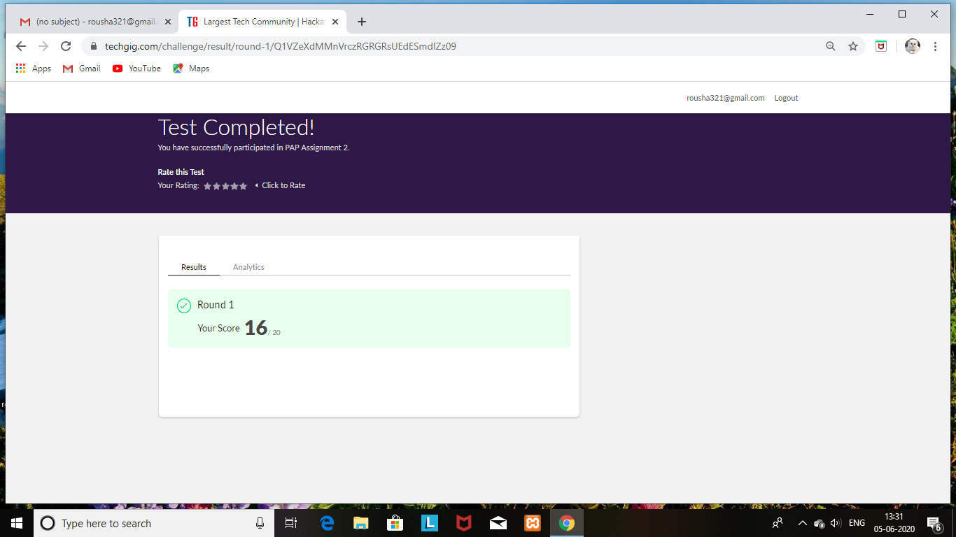

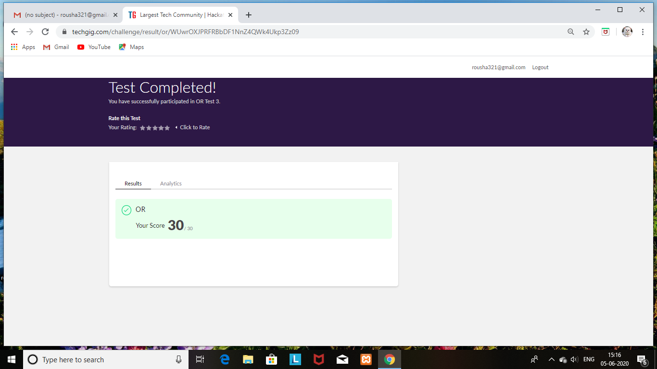

Certification Course Details: (Attach the snapshot and briefly write the report for the same)

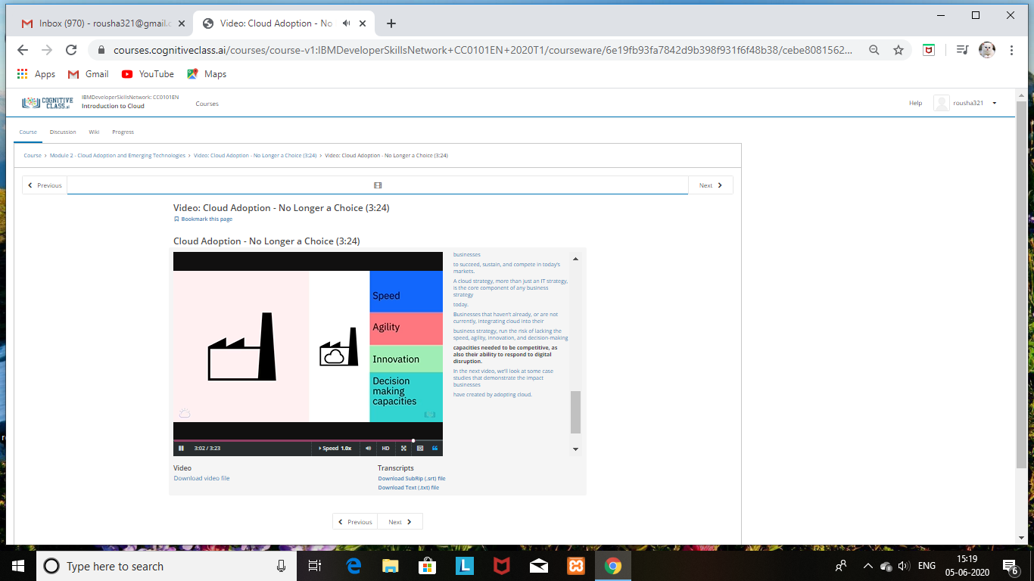

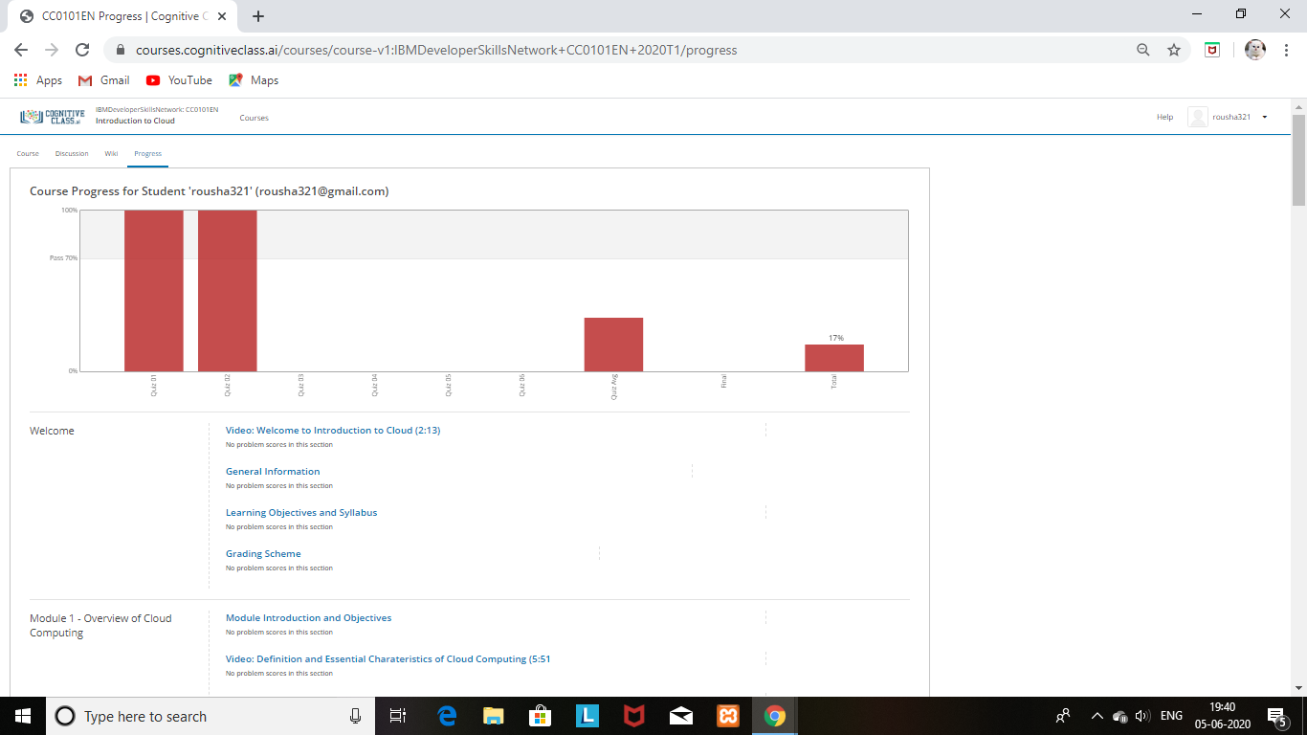

Shaifa:

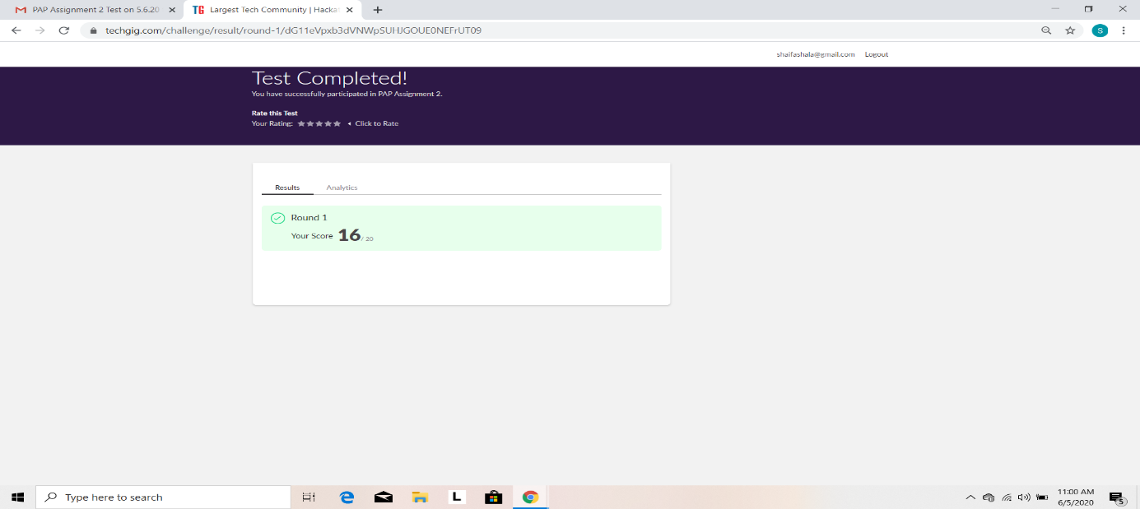

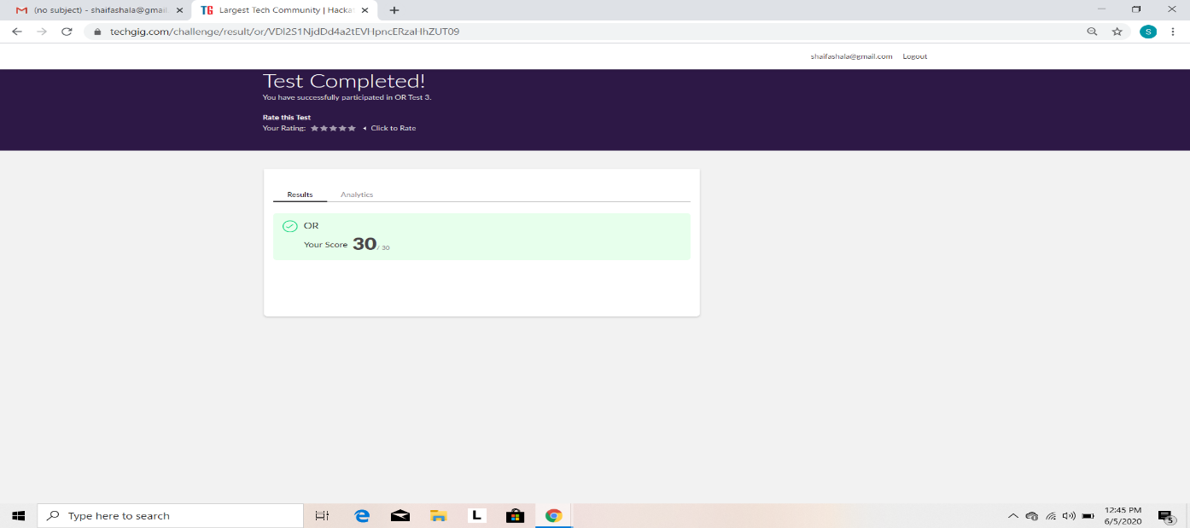

Certification Course Details: (Attach the snapshot and briefly write the report for the same)

